PROJECT REPORT
Implement Client Script & UI Policy (Incident)
Enforcing data integrity on ServiceNow Incident records
Team ID | 9100Orbit
Project Name | Implement Client Script & UI Policy (Incident)
Platform | ServiceNow (Incident Management)
Date | 08 October 2026
Team Members | To be added by the team

Table of Contents
1. Introduction
1.1 Project Overview
1.2 Purpose
2. Ideation Phase
2.1 Problem Statement
2.2 Empathy Map Canvas
2.3 Brainstorming
3. Requirement Analysis
3.1 Customer Journey Map
3.2 Solution Requirement
3.3 Data Flow Diagram
3.4 Technology Stack
4. Project Design
4.1 Problem Solution Fit
4.2 Proposed Solution
4.3 Solution Architecture
5. Project Planning & Scheduling
5.1 Project Planning
6. Functional and Performance Testing
6.1 Performance Testing
7. Results
7.1 Output Screenshots
8. Advantages & Disadvantages
9. Conclusion
10. Future Scope
11. Appendix

1. Introduction

1.1 Project Overview
Incident records need consistent and accurate data to support triage, routing and resolution. When this depends only on user awareness and manual checks, records can be saved incomplete or inconsistent, which affects reporting accuracy and SLA compliance.
This project uses ServiceNow client-side controls to enforce data rules directly on the Incident form and list. It includes:
- A UI Policy, "High Impact Control", that makes Assignment group mandatory and Urgency read-only when Impact is 1 - High, and reverses these effects when the condition is no longer true.
- An onChange client script that sets Urgency to High when Impact is changed to High.
- An onSubmit client script that blocks saving a High-impact incident without Assigned To.
- An onCellEdit client script that blocks State changes made directly in the Incident list.
- A test plan that confirms every rule works, including the reverse condition.

1.2 Purpose
- Show how UI Policies and Client Scripts enforce data integrity on Incident records.
- Make fields mandatory, read-only or auto-populated based on the Impact value.
- Prevent incomplete High-impact incidents from being saved.
- Prevent accidental State changes from the list view.
- Improve data quality and consistency across the platform.

2. Ideation Phase

2.1 Problem Statement
Incident records often require consistent and accurate data entry to ensure effective triage, routing and resolution. Relying solely on user awareness and manual checks can lead to incomplete, inconsistent or incorrect data being submitted, which impacts reporting accuracy, SLA compliance and overall service quality. There is a need to enforce conditional field behavior and validation directly at the user interface level.
Problem statement framed for the primary user (persona assumed for this project):
I am | A Service Desk Agent who logs and updates incidents.
I am trying to | Create High-impact incidents quickly with complete and correct information.
But | The form can be saved with no owner, a mismatched Urgency or an accidental State change.
Because | Data quality depends on manual checks instead of rules built into the form.
Which makes me feel | Worried about misrouted incidents, rework and missed SLAs.

2.2 Empathy Map Canvas
The empathy map is based on the assumed persona of a Service Desk Agent working with High-impact incidents.
Quadrant | What the Service Desk Agent experiences
Says | "I need to log this fast." "Who owns this incident?" "Why did the State change?"
Thinks | "If I miss a field, the incident may go to the wrong team." "High impact must get attention quickly."
Does | Opens the Incident form, enters caller and short description, selects Impact and Urgency, assigns a group and user, saves; edits State from lists to save time.
Feels | Pressure on High-impact incidents; anxious about SLA breaches; frustrated by rework.
Pain | Incomplete records, inconsistent Urgency, accidental list edits, no clear guidance on required fields.
Gain | Clear rules built into the form, instant error messages, consistent data, confidence that the incident is routed correctly.

2.3 Brainstorming
Ideas considered for enforcing data integrity on Incident records, and the decision taken:
No. | Idea | Decision | Reason
1 | UI Policy to make Assignment group mandatory when Impact is High | Selected | Declarative, no code, reverses automatically
2 | UI Policy action to make Urgency read-only for High impact | Selected | Keeps priority consistent
3 | onChange client script to set Urgency when Impact becomes High | Selected | Removes a manual step and shows an info message
4 | onSubmit client script to block save without Assigned To | Selected | Immediate feedback before the record is saved
5 | onCellEdit client script to block State edits in the list | Selected | Stops accidental changes outside the form
6 | Server-side business rule or data policy for the same checks | Future scope | Needed to cover integrations and imports
7 | Role-based exceptions for the list-edit block | Future scope | Would allow trusted roles to edit State in the list

3. Requirement Analysis

3.1 Customer Journey Map
Persona: Service Desk Agent logging and updating High-impact incidents. The map is shown in two parts: Part A covers Entice, Enter and Engage; Part B covers Exit and Extend.
Part A: Entice, Enter and Engage
SCENARIO  Creating, validating and updating a High-impact Incident | Entice  How does the agent become aware of this process? |  | Enter  What does the agent experience as they begin? |  | Engage  In the core moments, what happens?
Steps  What does the agent typically experience? | Incident reported  A caller reports a major outage to the service desk. | Open new Incident  Agent goes to Incident > Create New. | Enter details  Agent fills Caller, Category and Short description. | Set Impact to High  Agent selects 1 - High in the Impact field. | Urgency auto-set  onChange script sets Urgency to High and shows an info message. UI Policy makes Urgency read-only and Assignment group mandatory. | Submit without Assigned To  onSubmit script blocks the save and shows an error under Assigned To. | Assign and submit  Agent picks a user in Assigned To and the incident saves.
Interactions  Places, people and things at each step | ServiceNow Service Desk, caller by phone or email | Navigator: Incident > Create New  Incident form (new record) | Incident form fields  Caller lookup, Category choice list | Impact choice list  UI Policy High Impact Control fires when Impact is 1 - High | Urgency field, info message banner  onChange client script, UI Policy action | Submit button, Assigned To field  onSubmit client script, error box | Assigned To lookup, Submit button
Goals & motivations  Help me... or Help me avoid... | Help me capture the issue quickly | Help me start a record without hassle | Help me enter accurate basic information | Help me flag this as a high-priority issue | Help me avoid inconsistent Urgency  Help me know a group must own this | Help me avoid saving an incomplete record | Help me finish and be sure it is saved
Positive moments  What feels easy, helpful or reassuring? |  |  | Familiar form layout | Impact choices are clear | Urgency fills in automatically, one less decision | Clear message right at the field that needs fixing | Successful save confirms the rules were met
Negative moments  What feels frustrating or confusing? |  |  | Easy to skip fields when in a hurry | Agent may not know which follow-up fields will be required | Read-only Urgency can surprise agents who expected to edit it | Save is blocked only after the agent clicks Submit
Areas of opportunity  How might we make each step better? | Capture impact questions in the call script |  | Highlight key fields early with a UI Policy | Show a note when Impact is High explaining what will change | Explain in the info message why Urgency is locked | Make Assigned To mandatory through a UI Policy so the error appears before Submit | Auto-suggest an assignee based on assignment group
Part B: Exit and Extend
SCENARIO  Creating, validating and updating a High-impact Incident | Exit  What happens as the process finishes? |  |  | Extend  What happens after the incident is saved?
Steps  What does the agent typically experience? | Lower Impact to Medium  Reverse if false makes Urgency editable and Assignment group optional again. | Edit State in list  onCellEdit script shows an alert and cancels the change. | Update State on form  Agent changes State on the form and clicks Update; it saves. | Reporting and SLA  Complete, consistent records feed dashboards and SLA tracking. | Refine the rules  Admin reviews results and extends the policies.
Interactions  Places, people and things at each step | Impact field on an open incident  UI Policy reverse logic | Incident list view (Incident > All)  onCellEdit client script, browser alert | Incident form, State field, Update button | Dashboards, reports, SLA definitions  Service Desk manager | System UI > UI Policies and Client Scripts  ServiceNow admin
Goals & motivations  Help me... or Help me avoid... | Help me correct a wrong impact without leftover restrictions | Help me avoid accidentally changing State | Help me move the incident forward the right way | Help me trust the numbers I report | Help me keep rules relevant as needs change
Positive moments  What feels easy, helpful or reassuring? | Form relaxes instantly when Impact changes | Clear alert explains why the edit was blocked | Form updates work normally | Cleaner, more consistent data | Easy to adjust policies without platform changes
Negative moments  What feels frustrating or confusing? | Urgency stays at its earlier value until edited | Blocked list edit can feel slow for quick updates |  |  | Too many rules could make the form feel restrictive
Areas of opportunity  How might we make each step better? | Re-calculate Urgency when Impact is lowered | Offer an Open incident shortcut inside the alert | Add a State-change checklist on the form | Build a data-quality dashboard for High-impact incidents | Review policies each quarter with the Service Desk team

3.2 Solution Requirement
Functional Requirements
FR No. | Functional Requirement (Epic) | Sub Requirement (Story / Sub-Task)
FR-1 | High Impact Control (UI Policy) | Make Assignment group mandatory when Impact is 1 - High
FR-1 | High Impact Control (UI Policy) | Make Urgency read-only when Impact is 1 - High
FR-1 | High Impact Control (UI Policy) | Reverse the policy effects when Impact is no longer High (Reverse if false)
FR-2 | Auto-populate Urgency (onChange Client Script) | Set Urgency to 1 - High automatically when Impact is changed to High
FR-2 | Auto-populate Urgency (onChange Client Script) | Show the info message "Urgency set to High for High impact incident."
FR-3 | Save Validation (onSubmit Client Script) | Prevent saving a High-impact incident when Assigned To is empty
FR-3 | Save Validation (onSubmit Client Script) | Show an error message on the Assigned To field
FR-3 | Save Validation (onSubmit Client Script) | Allow the incident to save once Assigned To is filled
FR-4 | List Edit Control (onCellEdit Client Script) | Block changes to the State field when edited directly in the list view
FR-4 | List Edit Control (onCellEdit Client Script) | Show the alert "State cannot be updated using list editing. Please open the Incident."
FR-4 | List Edit Control (onCellEdit Client Script) | Keep the State value unchanged after the blocked edit
FR-5 | Form-Based Update | Allow State changes made on the Incident form and saved with Update
FR-5 | Form-Based Update | Keep Assigned To and Urgency following the configured UI Policy and Client Script rules
FR-6 | Configuration and Testing | Create the UI Policy, policy actions and three client scripts on the Incident table with administrative access
FR-6 | Configuration and Testing | Test mandatory enforcement, successful save, reverse condition, list edit blocking and form-based update
Non-functional Requirements
NFR No. | Non-Functional Requirement | Description
NFR-1 | Usability | Clear error, info and alert messages appear next to the affected field or as a pop-up. Mandatory fields are marked and the rules apply instantly without reloading the page.
NFR-2 | Security | Only users with administrative or configuration access can create or change UI Policies and Client Scripts. Scripts run in isolated script mode. Client-side rules improve data entry but do not replace server-side controls such as ACLs and business rules.
NFR-3 | Reliability | Rules apply consistently on every create and update. Reverse if false restores fields when the condition is no longer met, and the scripts ignore form load and empty values without errors.
NFR-4 | Performance | Scripts are lightweight and run in the browser without extra server calls, so the Incident form opens and responds with no noticeable delay.
NFR-5 | Availability | The UI Policy and Client Scripts are Active and global, so they are available whenever the Incident form or list is used on the ServiceNow instance.
NFR-6 | Scalability | Rules are scoped to the Incident table and apply to all incidents. New fields or conditions can be added as extra UI Policy actions or scripts without redesigning the solution.

3.3 Data Flow Diagram
The Level 0 data flow diagram shows how an Incident record moves through the UI Policy and Client Script controls before it is saved.
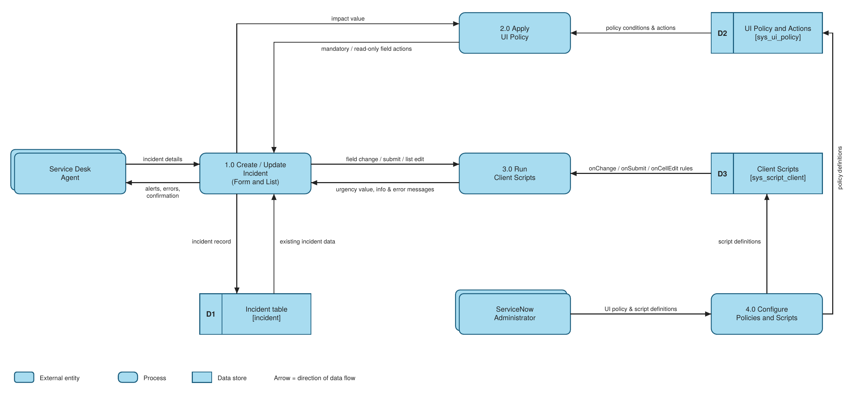
Figure 3.3: DFD Level 0 - Incident Client Script and UI Policy
Flow
1. The Service Desk Agent enters incident details (caller, category, impact, short description) on the Incident form, or edits a field from the Incident list.
2. The form sends the Impact value to the UI Policy (2.0). It reads the policy conditions from the UI Policy store (D2). When Impact is 1 - High, Assignment group becomes mandatory and Urgency becomes read-only. These effects are reversed when the condition is no longer true.
3. The Client Scripts process (3.0) reads the script rules from the Client Script store (D3). onChange sets Urgency to High with an info message, onSubmit blocks saving a High-impact incident without Assigned To, and onCellEdit blocks State changes from the list.
4. Messages, errors or alerts return to the agent. When all rules pass, the incident record is saved in the Incident table (D1) and the agent receives confirmation.
5. The Administrator defines the UI Policy, policy actions and client scripts in the Configure process (4.0), which stores them in D2 and D3.
User Stories
User Type | Functional Requirement (Epic) | User Story Number | User Story / Task | Acceptance criteria | Priority | Release
Service Desk Agent | High Impact Control (UI Policy) | USN-1 | As an agent, I want Assignment group to become mandatory when Impact is High, so that high-impact incidents are always routed to a team. | Assignment group is mandatory when Impact = 1 - High | High | Sprint-1
Service Desk Agent | High Impact Control (UI Policy) | USN-2 | As an agent, I want Urgency to become read-only when Impact is High, so that priority stays consistent. | Urgency is visible but cannot be edited while Impact = High | High | Sprint-1
Service Desk Agent | High Impact Control (UI Policy) | USN-3 | As an agent, I want the restrictions removed when I lower the Impact, so that I can work normally on lower-impact incidents. | With Impact = 2 - Medium, Assignment group is optional and Urgency is editable (Reverse if false) | Medium | Sprint-1
Service Desk Agent | Auto-populate (onChange Client Script) | USN-4 | As an agent, I want Urgency to be set to High automatically when I choose High Impact, so that I do not enter it manually. | Urgency = 1 - High and the info message "Urgency set to High for High impact incident." appears | High | Sprint-2
Service Desk Agent | Save validation (onSubmit Client Script) | USN-5 | As an agent, I want to be stopped from saving a High-impact incident without Assigned To, so that no incident is left without an owner. | Save is blocked and the error "Assigned To is mandatory for High impact incidents." appears on the field | High | Sprint-2
Service Desk Agent | Save validation (onSubmit Client Script) | USN-6 | As an agent, I want to save the incident once Assigned To is filled, so that I can complete the record. | Incident saves successfully with no errors | High | Sprint-2
Service Desk Agent | List edit control (onCellEdit Client Script) | USN-7 | As an agent, I want State changes from the list view to be blocked, so that State is not changed by accident. | Alert "State cannot be updated using list editing. Please open the Incident." appears and State stays unchanged | Medium | Sprint-3
Service Desk Agent | List edit control (onCellEdit Client Script) | USN-8 | As an agent, I want to change State from the Incident form, so that I can still update the incident properly. | State change made on the form saves successfully | Medium | Sprint-3
Administrator | Configuration | USN-9 | As an administrator, I want to create the UI Policy "High Impact Control" with its actions, so that field behavior is controlled by Impact. | Active policy on the Incident table with condition Impact is 1 - High; actions for Assignment group and Urgency | High | Sprint-1
Administrator | Configuration | USN-10 | As an administrator, I want to create the onChange, onSubmit and onCellEdit client scripts on Incident, so that data rules are enforced on the form and list. | Three active client scripts saved on the Incident table and working in tests | High | Sprint-2
Service Desk Manager | Data quality and reporting | USN-11 | As a manager, I want complete and consistent incident data, so that reports and SLA tracking are accurate. | Every High-impact incident has an Assignment group and an Assigned To value | Medium | Sprint-3

3.4 Technology Stack
The solution runs fully on the ServiceNow platform. The Service Desk Agent works in the browser, where the UI Policy and Client Scripts run on the client side, while the ServiceNow cloud instance stores incident data and the rule definitions. No external API or machine learning model is used.
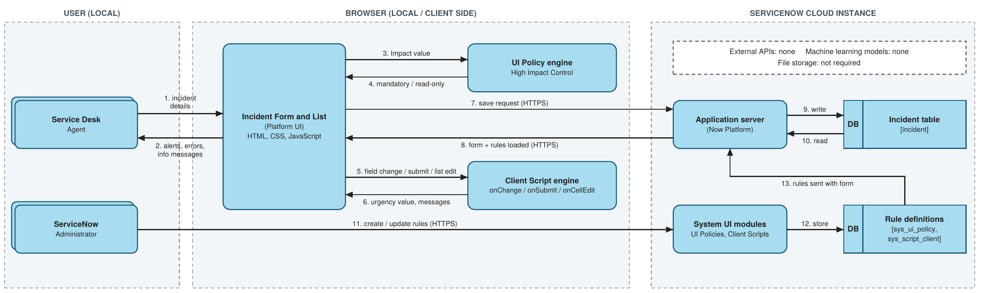
Figure 3.4: Technical architecture
Table-1: Components & Technologies
S.No | Component | Description | Technology
1. | User Interface | How the agent interacts with the application: Incident form (create / update) and Incident list view in the browser | ServiceNow Platform UI; HTML, CSS, JavaScript in the browser
2. | Application Logic-1 | UI Policy "High Impact Control": when Impact is 1 - High, Assignment group becomes mandatory and Urgency becomes read-only; effects are reversed when the condition is false | ServiceNow UI Policy and UI Policy Actions (no-code)
3. | Application Logic-2 | onChange client script on Impact: sets Urgency to High and shows an info message | JavaScript, GlideForm API (g_form.setValue, g_form.addInfoMessage)
4. | Application Logic-3 | onSubmit client script: blocks saving a High-impact incident when Assigned To is empty and shows an error on the field | JavaScript, GlideForm API (g_form.getValue, g_form.showErrorBox)
5. | Application Logic-4 | onCellEdit client script on State: blocks State changes made directly in the list and shows an alert | JavaScript, onCellEdit callback, browser alert
6. | Database | Incident records and rule definitions are stored in platform tables (incident, sys_ui_policy, sys_script_client) | ServiceNow platform relational database
7. | Cloud Database | Database service provided with the ServiceNow cloud instance used for this project (developer instance) | ServiceNow cloud-hosted instance database
8. | File Storage | Not required. This solution does not store files | Not applicable (ServiceNow attachments available if needed)
9. | External API | Not used. All logic runs inside the ServiceNow platform and browser | Not applicable
10. | Machine Learning Model | Not used in this project | Not applicable
11. | Infrastructure (Server / Cloud) | Local: user web browser only, no local server needed. Cloud: ServiceNow-managed instance that hosts the application, database and rules | Local: web browser. Cloud: ServiceNow cloud instance
Table-2: Application Characteristics
S.No | Characteristics | Description | Technology
1. | Open-Source Frameworks | No extra open-source framework is added. Client scripts use standard JavaScript on the ServiceNow platform | JavaScript (ECMAScript), ServiceNow GlideForm API
2. | Security Implementations | Login authentication for every user; only administrative or configuration access can create UI Policies and Client Scripts; scripts run in isolated (strict) mode without direct DOM access; traffic to the instance uses HTTPS. Client-side checks do not replace server-side ACLs and business rules | Role-based access control, ACLs, HTTPS / TLS, isolate script
3. | Scalable Architecture | Multi-tier platform (browser client, application server, database). Rules are defined once on the Incident table and apply to every incident; new rules can be added as extra UI Policy actions or scripts | ServiceNow multi-tier cloud architecture
4. | Availability | The application runs on a ServiceNow-managed cloud instance. UI Policy and Client Scripts are Active and Global, so they are available whenever the instance is available | ServiceNow cloud hosting
5. | Performance | Validations and field changes run in the browser, so no extra server round trip is needed. Scripts are short and lightweight, so the form responds immediately | Client-side execution (UI Policy, Client Scripts)

4. Project Design

4.1 Problem Solution Fit
Aspect | Description
Customer segment | Service Desk Agents and incident managers using ServiceNow Incident Management
Problem | Incidents can be saved incomplete or inconsistent because data quality depends on manual checks
Current alternatives | Training, reminders and after-the-fact clean-up of records
Solution | UI Policy and Client Scripts that enforce rules at the moment of data entry
Fit | The rules apply on every form and list interaction, give instant feedback and need no extra tools
Outcome | Complete and consistent High-impact incidents, better routing, more reliable reporting and SLA tracking

4.2 Proposed Solution
Item | Description
Problem to be solved | Incomplete and inconsistent Incident data caused by manual checks
Idea / solution | Use one UI Policy and three Client Scripts (onChange, onSubmit, onCellEdit) to control fields, auto-populate Urgency, validate on save and block list edits
Novelty | Combines declarative UI Policy and scripted Client Script controls on one table with a tested reverse condition
Customer satisfaction | Clear messages guide agents; incidents reach the right team with the right data
Business model | Not a revenue product. The value is less rework and better SLA compliance for the service desk
Scalability | Rules are defined once on the Incident table and apply to all incidents; new fields or conditions can be added as extra actions or scripts

4.3 Solution Architecture
The solution has three layers, shown in Figure 3.4 and the data flow in Figure 3.3:
Layer | Components | Role
Presentation (browser) | Incident form and Incident list | Where the agent enters and edits data
Control (client side) | UI Policy "High Impact Control"; onChange, onSubmit and onCellEdit client scripts | Apply field behavior, auto-populate Urgency, validate on save and block list edits
Data (ServiceNow cloud) | Incident table; rule definitions (sys_ui_policy, sys_script_client) | Store incident records and the rules that control them
Administration | ServiceNow Administrator using System UI > UI Policies and Client Scripts | Create and maintain the rules
Runtime behavior: when the form loads, the rules are sent to the browser with it. Changing Impact triggers the UI Policy and the onChange script. Clicking Submit runs the onSubmit script, and only a passing record is sent to the server and saved in the Incident table.

5. Project Planning & Scheduling

5.1 Project Planning
The work was organised into three sprints using the user stories from Section 3.3. Sprint dates can be added by the team.
Sprint | Functional Requirement (Epic) | User Stories | Sprint Outcome | Status
Sprint-1 | High Impact Control (UI Policy); Configuration | USN-1, USN-2, USN-3, USN-9 | UI Policy "High Impact Control" created with actions for Assignment group (mandatory) and Urgency (read-only), Reverse if false enabled | Completed
Sprint-2 | Auto-populate Urgency; Save validation; Configuration | USN-4, USN-5, USN-6, USN-10 | onChange and onSubmit client scripts created and active on the Incident table | Completed
Sprint-3 | List edit control; Form-based update; Data quality | USN-7, USN-8, USN-11 | onCellEdit client script created; full testing and verification completed | Completed

6. Functional and Performance Testing
Functional test cases were run on the ServiceNow instance using the steps in the project testing tasks. Results are taken from the test output screenshots in Section 7.
Test ID | Scenario | Expected result | Actual result | Status
TC-1 | Set Impact to 1 - High on a new incident | Assignment group becomes mandatory | Assignment group shown as mandatory | Pass
TC-2 | Set Impact to 1 - High | Urgency becomes read-only | Urgency shown greyed out and not editable | Pass
TC-3 | Change Impact to 1 - High (onChange) | Urgency set to 1 - High with info message | Urgency set to 1 - High automatically | Pass
TC-4 | Save a High-impact incident with Assigned To empty (onSubmit) | Save blocked, error shown on Assigned To | Incident not saved; error "Assigned To is mandatory for High impact incidents." shown | Pass
TC-5 | Fill Assigned To and click Submit | Incident saves without errors | Incident saved successfully | Pass
TC-6 | Change Impact from High to Medium on an existing incident | Assigned To optional, Urgency editable, record saves | Restrictions removed and record saves | Pass
TC-7 | Double-click State in the Incident list (onCellEdit) | Alert shown and State unchanged | Alert "State cannot be changed from the list. Please open the Incident." shown; State unchanged | Pass
TC-8 | Change State on the Incident form and click Update | State change saves | State saved as In Progress | Pass
Observation: after Impact is changed from High to Medium, Urgency stays at its earlier value (1 - High) but becomes editable. The onChange script sets Urgency only when Impact becomes High.

6.1 Performance Testing
No formal load or timing tests were run for this micro project, so no measured figures are reported. The observations below are qualitative and come from the testing sessions and the design of the solution.
Aspect | Observation
Responsiveness | UI Policy effects, info messages, error boxes and alerts appeared immediately during testing
Server load | Validations run in the browser, so they need no extra server request
Script size | The three scripts are short and use simple checks on field values
Form load | The form loaded normally with the rules active; no delay was observed

7. Results

7.1 Output Screenshots
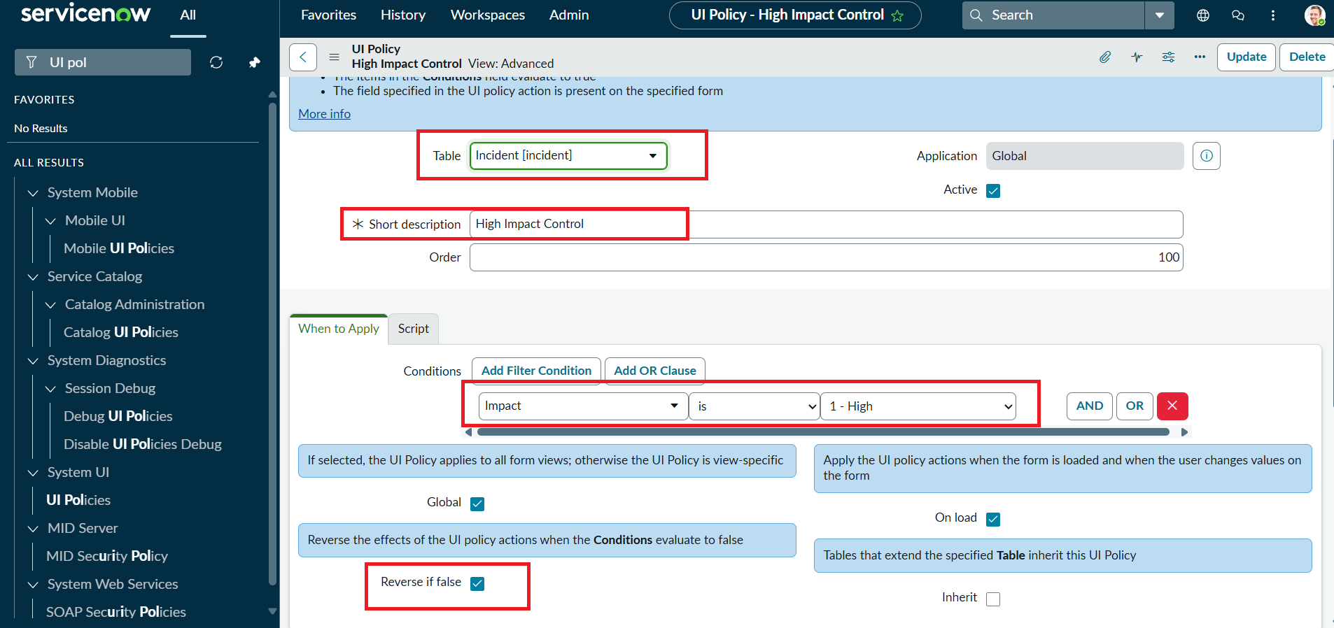
Figure 7.1: UI Policy "High Impact Control" with condition Impact is 1 - High and Reverse if false
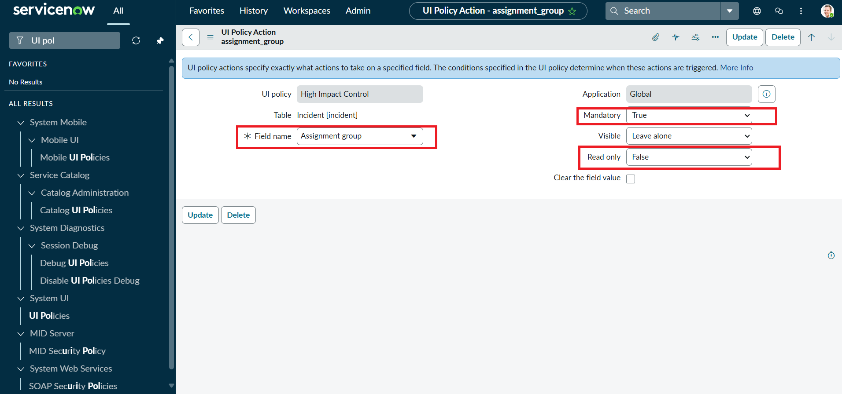
Figure 7.2: UI Policy action - Assignment group mandatory
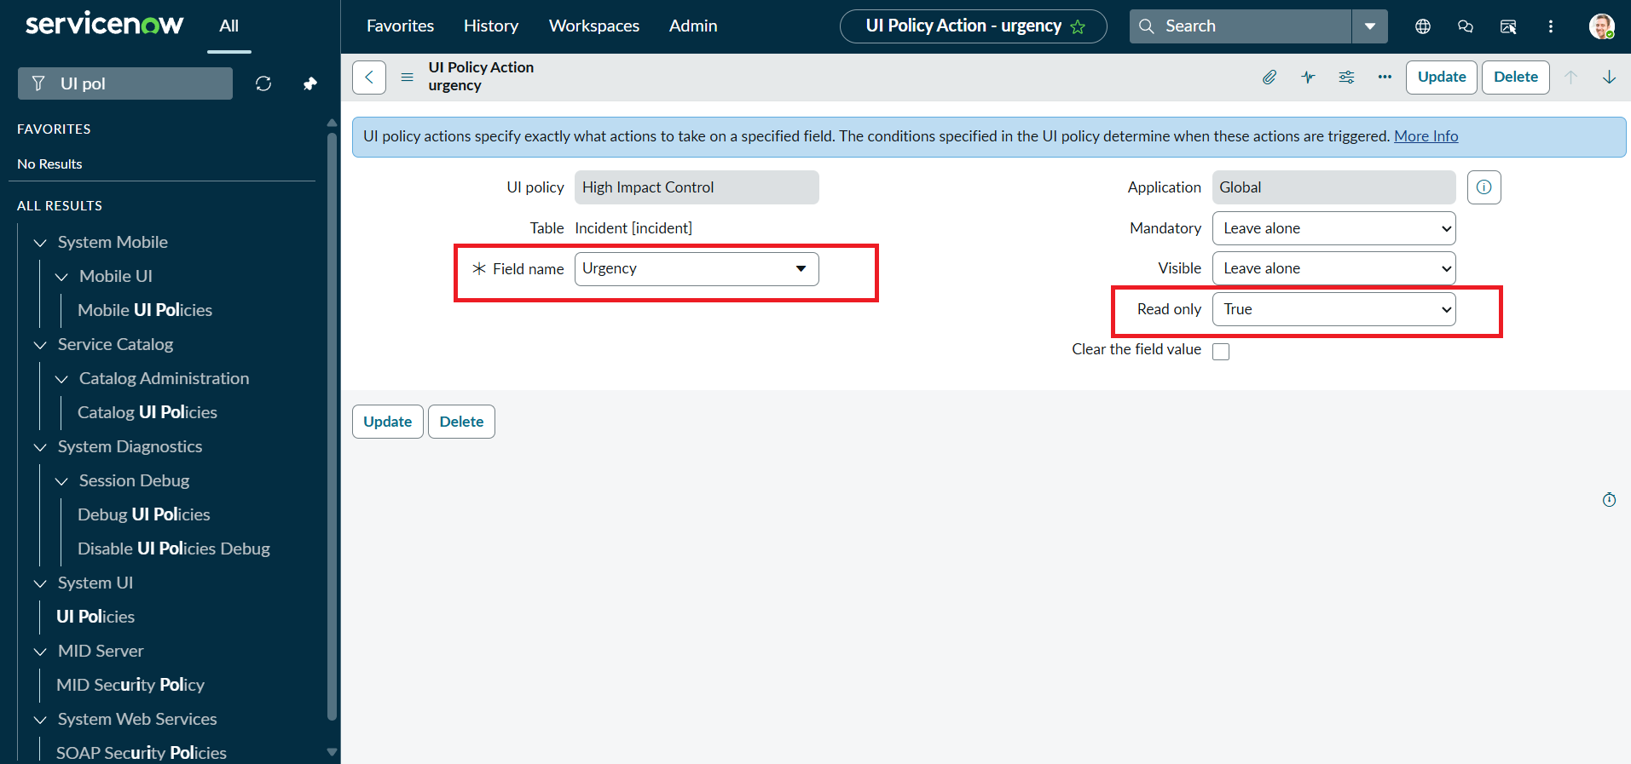
Figure 7.3: UI Policy action - Urgency read-only
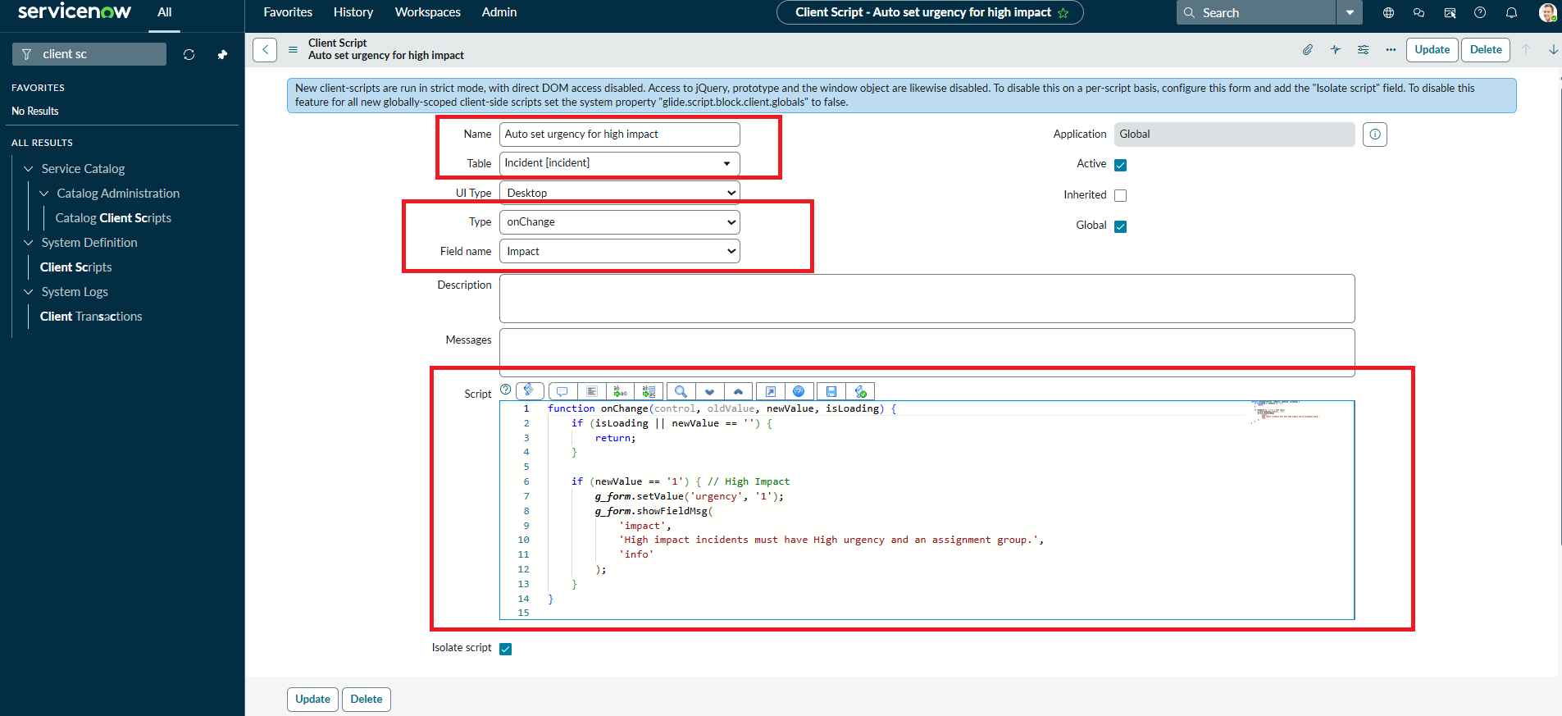
Figure 7.4: onChange client script "Auto set urgency for high impact"
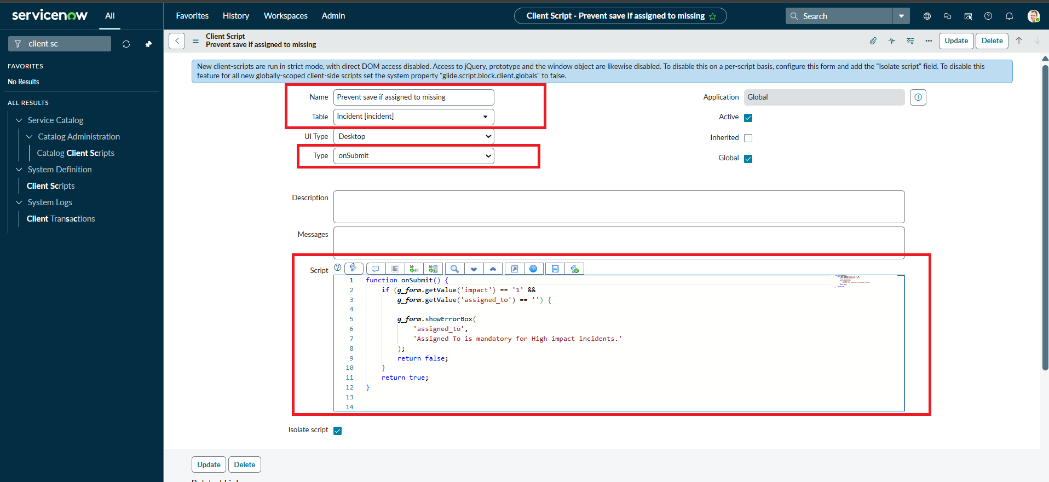
Figure 7.5: onSubmit client script "Prevent save if Assigned To missing"
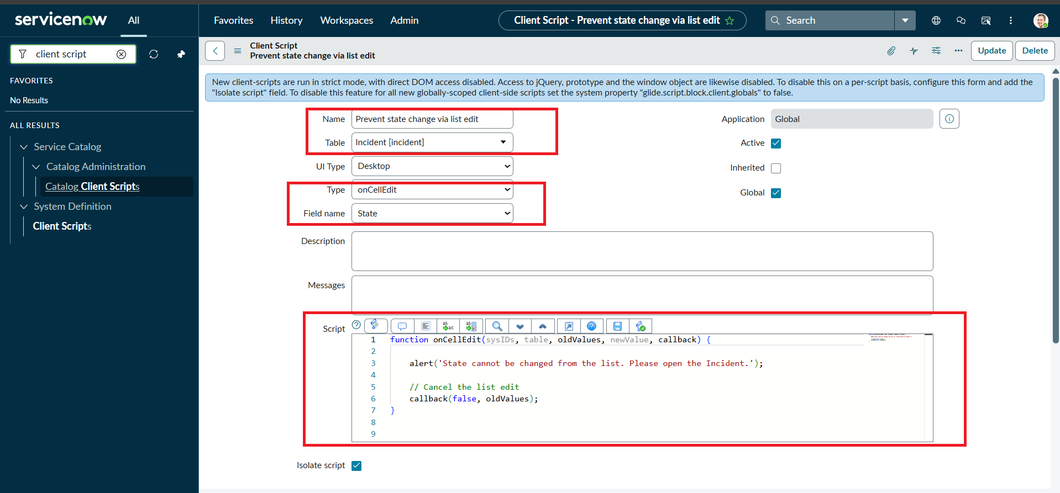
Figure 7.6: onCellEdit client script "Prevent state change via list edit"
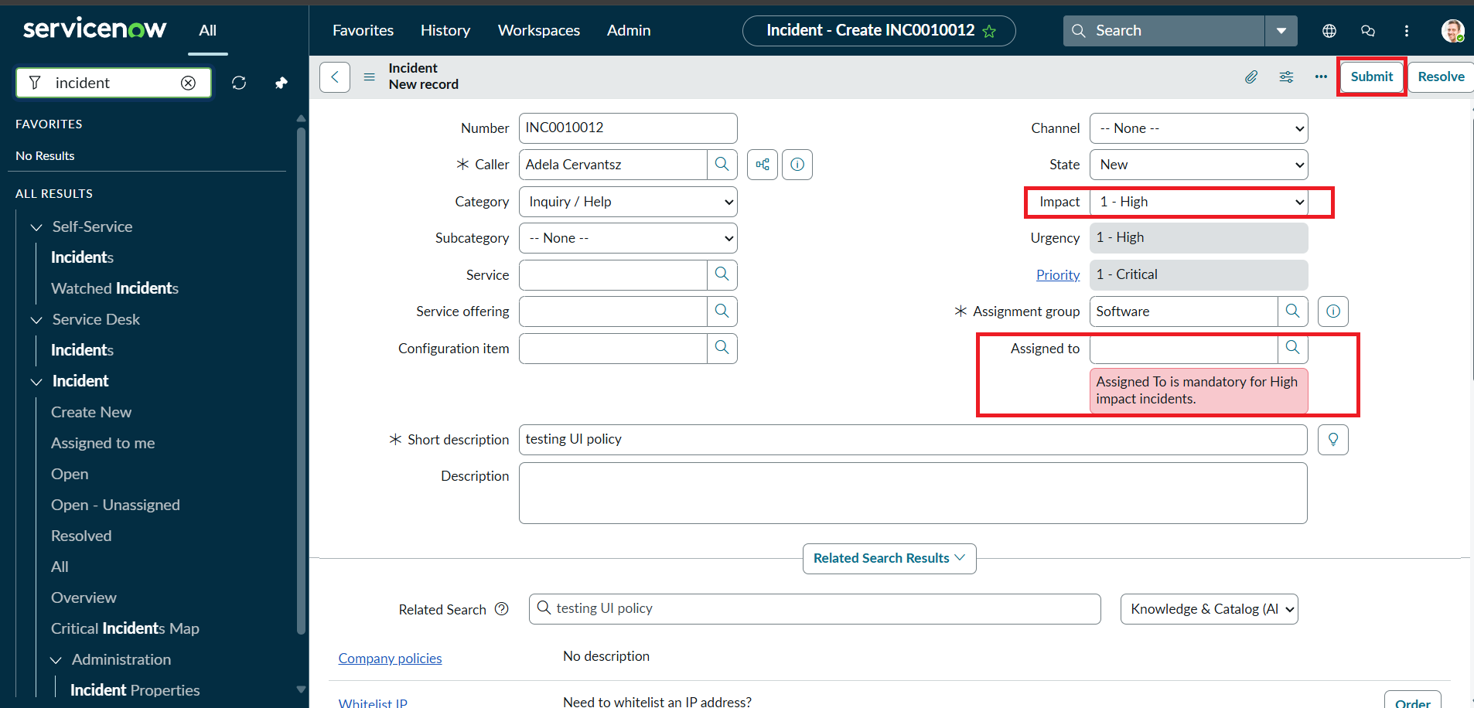
Figure 7.7: Save blocked - error shown on Assigned To for a High-impact incident
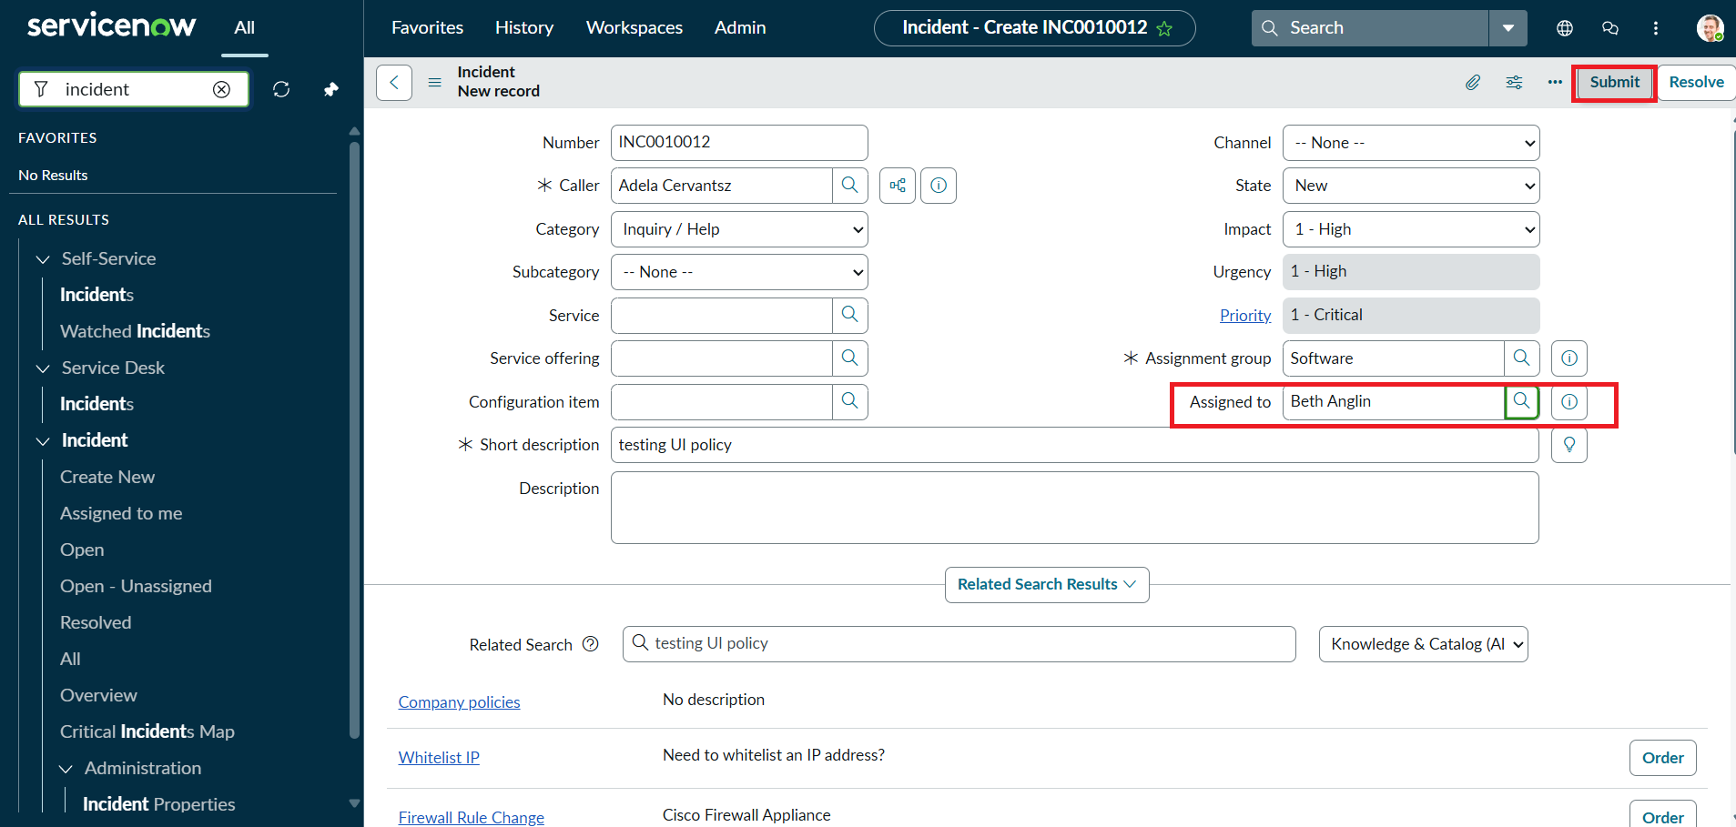
Figure 7.8: Incident saved after Assigned To is filled
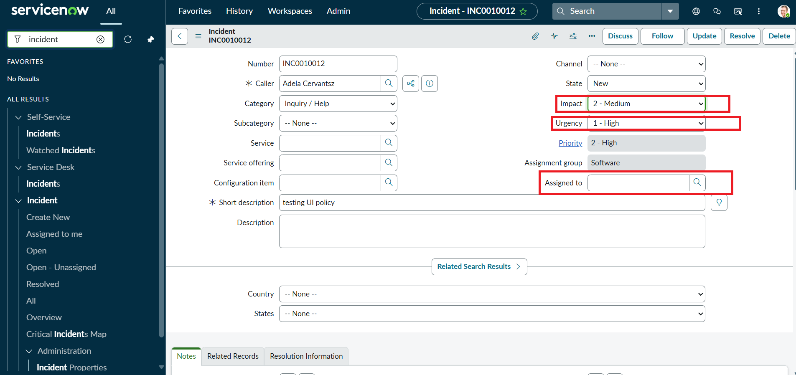
Figure 7.9: Reverse condition - Impact changed to Medium, Assigned To no longer mandatory
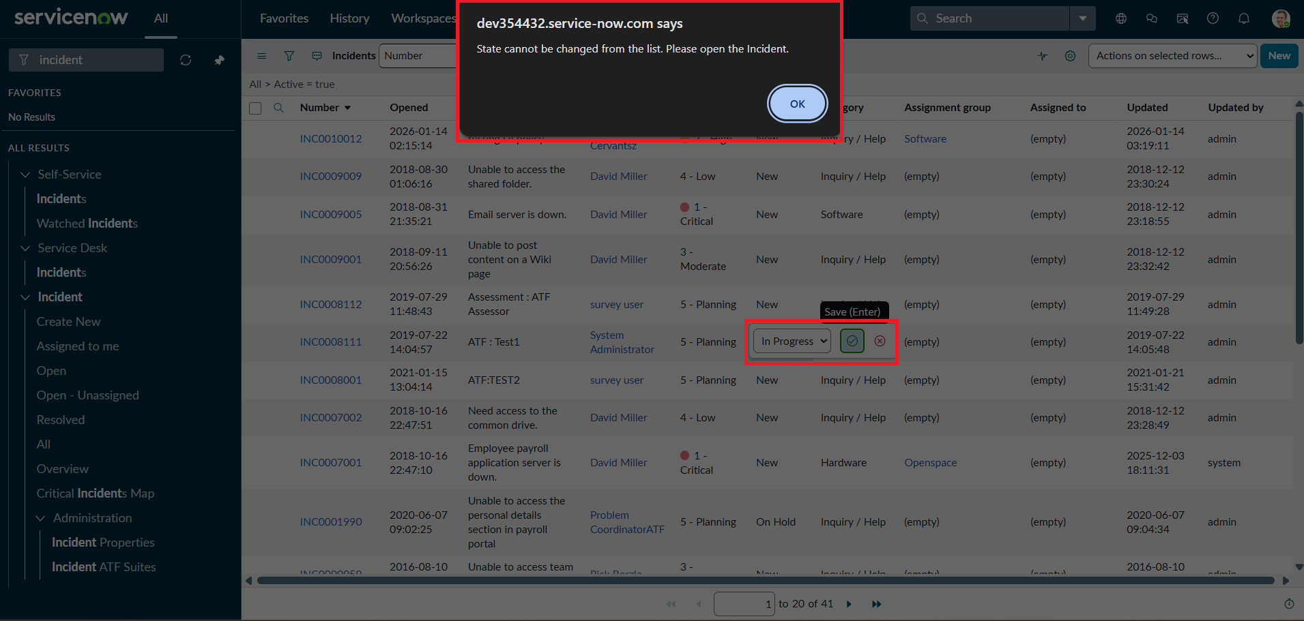
Figure 7.10: Alert shown when State is edited in the list
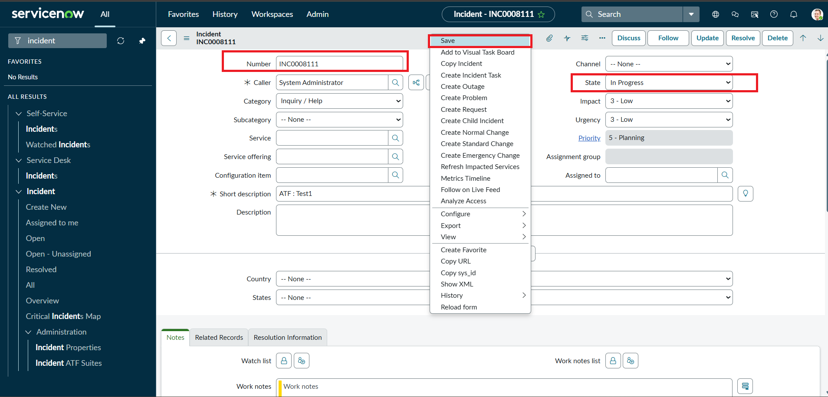
Figure 7.11: State updated from the Incident form
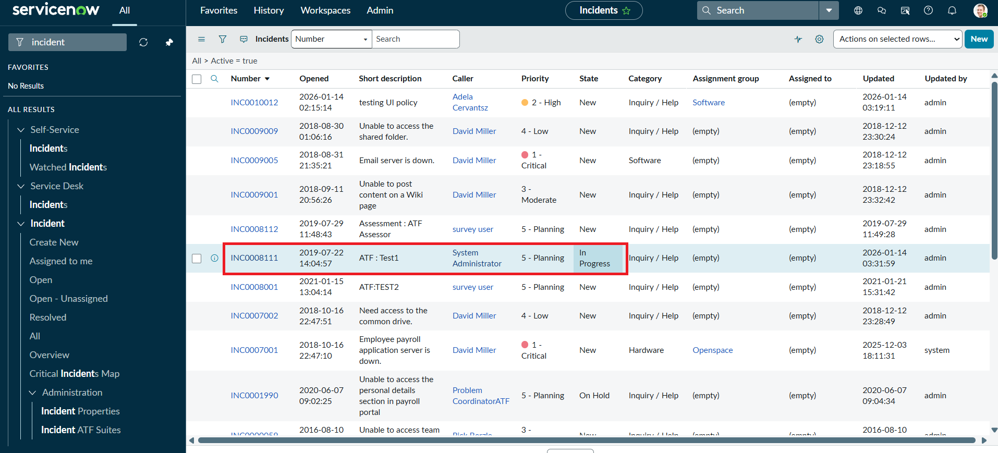
Figure 7.12: Incident list showing State In Progress after the form update

8. Advantages & Disadvantages
Advantages
- Enforces data rules at the point of entry, so errors are caught before the record is saved.
- Gives instant, clear feedback with info, error and alert messages.
- Uses standard ServiceNow features, so it is lightweight and easy to implement.
- Reverse if false removes the restrictions automatically when the condition no longer applies.
- Rules apply to every incident on the table and can be extended easily.
- Improves reporting accuracy and SLA compliance through consistent data.
Disadvantages
- Client-side rules do not apply to integrations, imports or background updates, so server-side rules are still needed for strict enforcement.
- The onCellEdit script blocks every State edit in the list for all users, with no role-based exception.
- Urgency is not reset when Impact is lowered from High; it only becomes editable.
- Values such as "1" (High) and the message texts are written directly in the scripts, so they need script edits to change.
- The scripts apply to the Desktop UI type, so other interfaces would need their own configuration.

9. Conclusion
The Implement Client Script & UI Policy (Incident) project shows how UI Policies and Client Scripts work together to enforce dynamic field behavior, automate updates and prevent incorrect data submission on Incident forms. By combining onChange, onSubmit and onCellEdit scripts with UI Policy actions, the project ensures that fields such as Assigned To and Urgency respond correctly to changes in Impact. All eight test cases passed. The solution is lightweight, efficient and easy to implement, and it supports clean and consistent data in ServiceNow.

10. Future Scope
- Add server-side business rules or data policies so the same checks apply to integrations and imports.
- Allow role-based exceptions, for example letting managers edit State in the list.
- Reset or recalculate Urgency when Impact is lowered.
- Move hard-coded values and messages into system properties or message records.
- Extend the controls to other tables such as Problem and Change.
- Add reporting on High-impact incidents to track data quality over time.

11. Appendix

Source Code
onChange client script: Auto set urgency for high impact (table: Incident, field: Impact)
function onChange(control, oldValue, newValue, isLoading) {
if (isLoading || newValue == '') {
return;
}
if (newValue == '1') {
g_form.setValue('urgency', '1');
g_form.addInfoMessage('Urgency set to High for High impact incident.');
}
}
onSubmit client script: Prevent save if Assigned To missing (table: Incident)
function onSubmit() {
if (g_form.getValue('impact') == '1' &&
g_form.getValue('assigned_to') == '') {
g_form.showErrorBox(
'assigned_to',
'Assigned To is mandatory for High impact incidents.'
);
return false;
}
return true;
}
onCellEdit client script: Prevent state change via list edit (table: Incident, field: State)
function onCellEdit(sysIDs, table, oldValues, newValue, callback) {
alert('State cannot be updated using list editing. Please open the Incident.');
callback(false);
}

Dataset Link
Not applicable. The project uses ServiceNow Incident records and does not use an external dataset.

GitHub & Project Demo Link
GitHub link: to be added by the team
Project demo link: to be added by the team

